Oyster Task Force Meeting
Tuesday, August 29, 2023, 1:00pm
New Orleans Lakefront Airport
6001 Stars and Stripes Blvd
New Orleans, LA 70126
I. Pledge of Allegiance
II. Roll call and introduction of guests
Voting Members Present:
Dan Coulon
Jakov Jurisic
Mitch Jurisich
Brad Robin
Brandt Lafrance
Al Sunseri
Matthew Slavich
Sam Slavich
Willie Daisy

Voting Members Absent:
Shane Bagala
Tracy Collins
Brandon Debarge
Peter Vujnovich
Steve Pollock

Non-Voting Members Present:
Robert Caballero
Edward Skena
Kyle Balkum
Isabel Englehart in for Harry Vorhoff
Brian Lezina

Non-Voting Members Absent:

III. Brad Robin motioned to approve the June 6, 2023 meeting minutes, 2nd by Jakov Jurisic. Motion carries.

Jakov Jurisic motioned to amend the August 29, 2023 meeting agenda by adding an item under New Business, G. To Consider Funding for Flower Expenses for an OTF board member, 2nd by Brad Robin. Motion Carries.

Jakov Jurisic motioned to approve the August 29, 2023 meeting agenda as amended, 2nd by Brad Robin. Motion carries.

IV. Treasury Report:
Remaining Fund Balance- $571,034
Remaining Budget Balance- $85,989
July Tag Sales- 150,000

Willie Daisy motioned to approve the treasury report as presented, 2nd by Brad Robin. Motion carries.

V. Committee Reports:
- Public-Private Oyster Seed Grounds Committee Report- no report
- Enforcement Report-
May 31st – August 21st
Region 4 (Iberia)- None
Region 5 (Calcasieu and Cameron)- None

Region 6: (Terrebonne, Lafourche, Grand Isle, St. Mary)

Terrebonne
40.4A Violate sanitation code (refrigeration)

St. Mary
56:424E(1) Take oyster from unapproved area (polluted)
40.4A Violate sanitation code (log book)
Seizures:41 Sacks
Region 8: (Jefferson, Plaquemines, St. Bernard, Orleans)
St. Bernard
1- RS 40: 4A – Violate Sanitation Code (Refrigeration) 1-RS 56: 303.2 A – Fail to have Commercial License in Possession
Seizures: 76 sacks
Plaquemines
1-RS 40: 4A – Violate Sanitation Code (Refrigeration) 1-RS 40:4A-Violate Sanitation Code (Log Book)
Seizures: 93 Sacks
- Legislative Committee Report- no report
- Legal Committee Report- no report
- Research Committee Report- Earl Melancon provided an update from the Research Committee- committee met prior to the OTF meeting heard a presentation from Dr. Dan Patrolia who did a commissioned study for LA Sea Grant that looked into the economics of AOC, the report is final and is available on LA Sea Grant’s website- https://www.laseagrant.org/2023/aoc-economics-study-finds-challenges/
- Coastal Restoration Committee Report- no report
- Marketing Report- Anna Koehl in the past have been focused on organic social media and content, this past month added in a spend for posts to reach a broader audience and received really positive results, added a minimal spend of $25 to boost post and received 5800 impressions, 450 reactions, 24 comments, 45 new page followers, would like to supplement with some paid social media posts to reach a broader more targeting audience, preliminary budget, would like the board to consider an $850 spend for September, $100 to boosting select posts and driving to website, $500 for double opt-in email for the month of September, guaranteed a minimum send of, website will attract at least 500 clicks
Jakov Jurisic motioned to add an agenda item under New Business, item H. To Consider $850 in Funding for OTF Social Marketing and Website Outreach, 2nd by Willie Daisy. Motion carries.
Anna Koehl stated that BMF issued a few op-eds one featured Matthew Slavich with the Advocate another with Willie Daisy, helped with one that may serve as some content for email that is set to go out
- Health Committee Report- Jen Armentor provided a report, have had 13 more additional vibrio illnesses which brings the total this year to 23 which is pretty substantial in comparison to previous years, regarding modifying the 1-hour to refrigeration, at this time don’t feel like this would be a good move given the increase in illnesses but it’s not off the table for possible future consideration. FDA has to have

The task force requested that LDH provide a breakdown and report on all the illnesses reported this year by the next meeting

Mr. Terry Shelley stated that he has an issue with dumping oysters due to paperwork and clerical errors, issues with something going wrong in paperwork like didn’t put start time and the whole oyster load is dumped, Mitch Jurisich stated that trying to get the agencies together to come to a solution on this, Jen Armentor stated that there is an opportunity to change from white to green tag as a corrective action but this is more for equipment failure not for a clerical error on paperwork, will look into this to see if we can look into solutions on this issue; the OTF sent this item to the Health Committee for further discussion

- Aquaculture Committee Report- no report
- Joint Task Force Working Group Report- no report
VI. New Business
- Jason Froeba provided an update on the 2019 Fisheries Disaster funding
- Flood Disaster Assistance: In 2019, extensive freshwater flooding caused significant impacts to coastal resources including oysters, shrimp, blue crabs, and finfish
- During the 2019-2020 fiscal year, Congress appropriated a total of $165 million for declared fisheries disasters in the United States
- National Oceanic and Atmospheric Administration (NOAA) allocated $58,284,841 of this funding to Louisiana
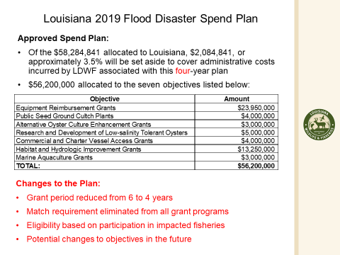
Spend Plan Implementation:
- Currently Ongoing
  - Research and Development of Low-salinity Tolerant Oysters
- Immediate Implementation
  - Equipment Reimbursement Grants
- Fiscal Year 23
  - Public Seed Ground Cultch Plants
  - Commercial and Charter Vessel Access Grants
- Feasibility Assessment
  - Alternative Oyster Culture Enhancement Grants
  - Habitat and Hydrologic Improvement Grants
  - Marine Aquaculture Grants
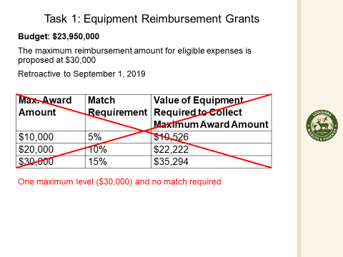
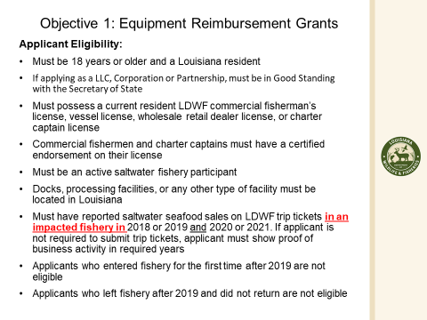
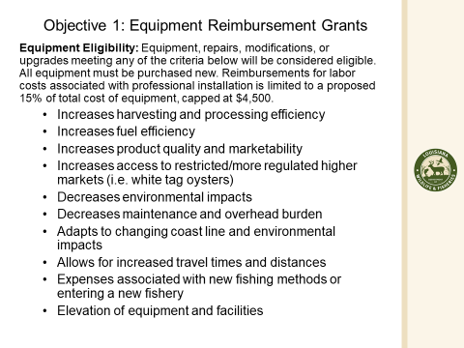
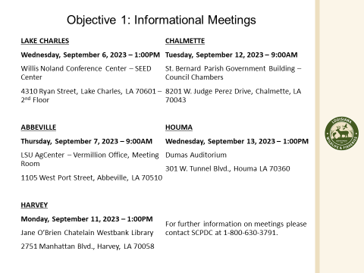
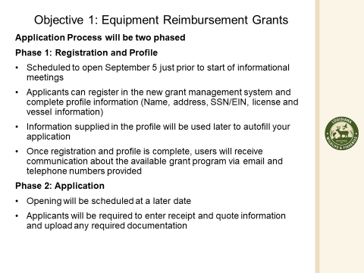
All license holders will receive a mailer about upcoming South Central meetings
Mitch Jurisich stated that the $5M for low salinity oyster should go by the wayside at this point, wouldn’t give up on hydrologic item would like to still get the failed Bohemia Salinity Control Structure closed, Plaquemines Parish submitted something to LDWF
Brad Robin stated to put the money back into the resources that were hurt due to the disaster not on a study, Jason Froeba stated that the issue with it is with the permit and the 4 year restriction from NOAA, trying to identify some options that would be a feasible to use of the money while still remaining in this time frame, requested extension and it was not granted, in terms of the research project that has been going on for several years now and at this point any changes to the original plan has to go through NOAA and we would have to start all over with the approval process
George Ricks expressed that there is concern about funding being taken back from NOAA for project, it seems a little hypocritical that the fishermen had to wait over 4 years for the funding, the timeframe should be part of the spending plan
Jason Froeba stated that there there may be a decision made on hurricane disasters for 2020 and 2021 seasons, expecting response any day now, will be some funding allocated for these, will have 120 days to develop a new spending plan for these disasters would like the task forces’ input on this, NOAA is also supposed to have 120 days to respond back on the spend plan as well, waiting on Secretary of Commerce’s approval of the disaster and how much money is being allocated
- Robert Caballero provided a presentation on the Public oyster stock assessment and the 2023/24 oyster season
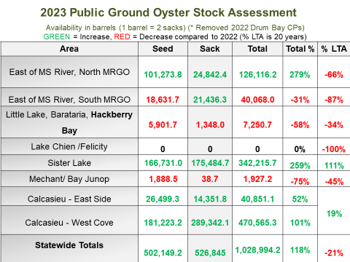
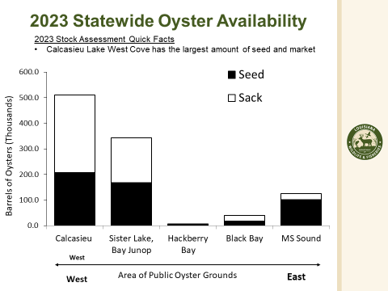
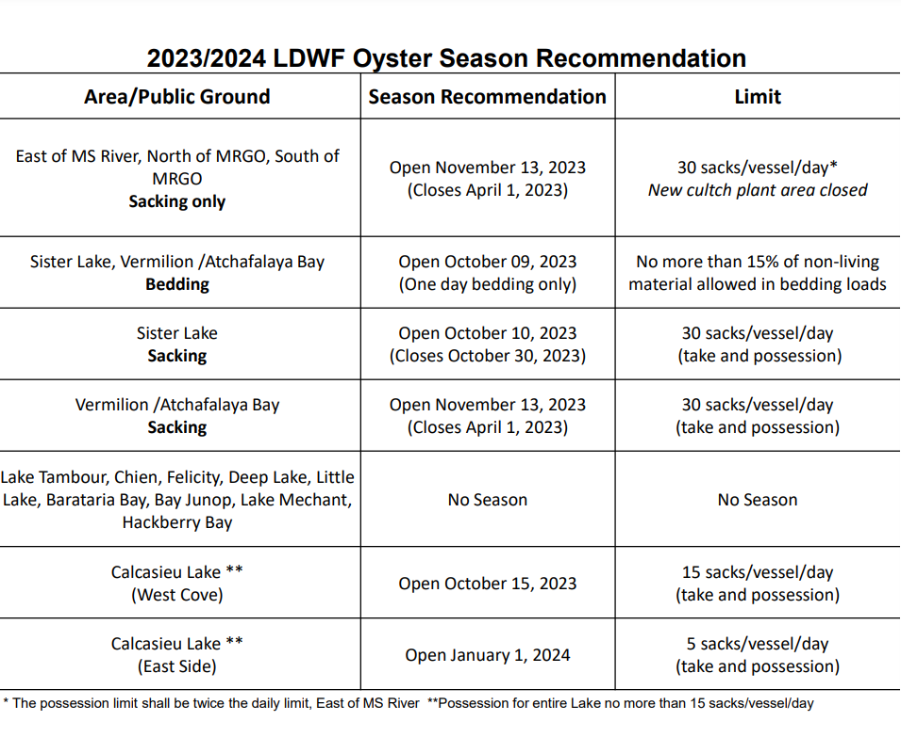
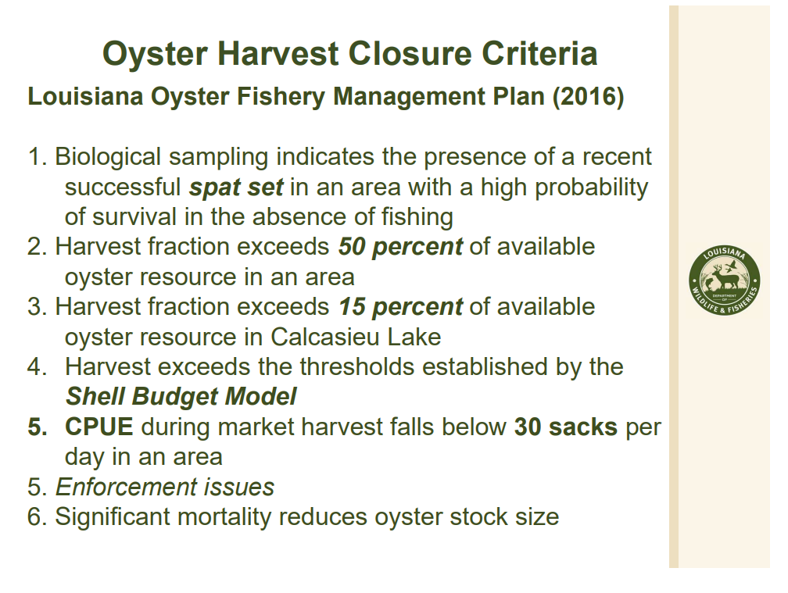
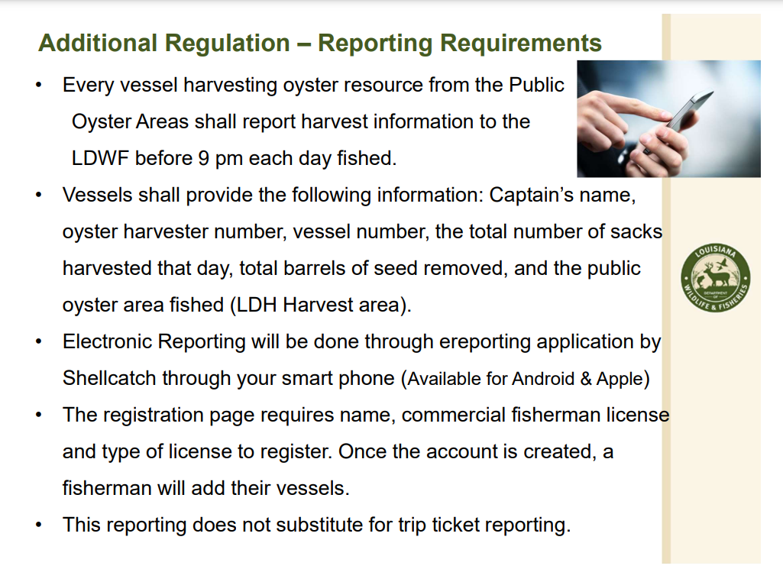Jakov Jurisic asked about getting copies of square meter samples, asked that this be provided to the task force
Robert Caballero stated that he is working going forward to have the oyster stock assessments to the Task force sooner, the turn-around time has been about a year, trying to have to the task force by next season
Brad Robin suggested that the task force try and do a Day in the Bay. In the past have found some resource that LDWF has not yet found, OTF planning to add this item for consideration and fuel funding on their next meeting agenda
Al Sunseri stated that closure in Vermillion/ Atchafalaya when does the line move? Robert Caballero stated that there will be a line determination for October and then again in March next season will set November- February and March will set a new closure line, Al Sunseri stated that there may be an opportunity to harvest marketable oysters in September or if some people want to plant early on this would be good to consider.
- Michael Harden provided an update on the public-grounds e-reporting application for the 2023/24 oyster season
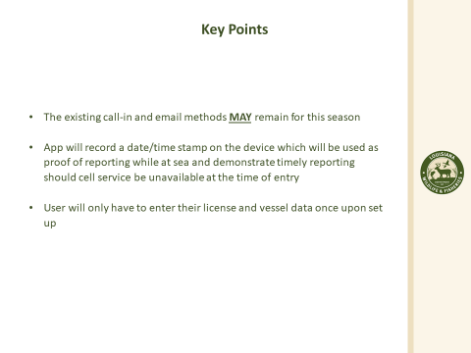
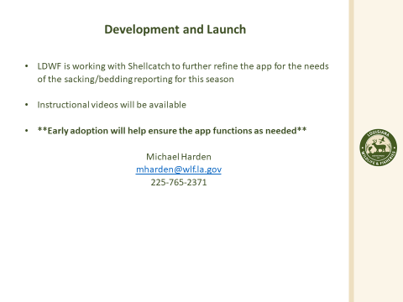
Task force requested that LDWF look into other options for those in the oyster industry who cannot operate a phone
- The task force took up item G. at this time and considered funding for flowers for the Vujnovich family
Sam Slavich motioned to fund sending a florla arrangement to the Vujnovich family from the Oyster Task Force, 2nd by Brad Robin. Motion carries.
- The task force took up item H. under new business at this time and considered funding for social and email marketing for the Oyster Task Force website and social media sites
Brad Robin motioned to dedicate $850 for additional paid social media and email marketing, 2nd by Willie Daisy. Motion carries.
- The board considered funding for travel to walk the hill and attend/ participate in the 2024 LA Alive event
Brad Robin motioned to fund board member travel, participation in a booth at the 2024 LA Alive event and bead purchase and delivery, 2nd by Brandt Lafrance. Motion carries.
- Dr. Maryam provided a presentation and update on the oyster harvesting cost calculations for the oyster lease damage evaluation board update
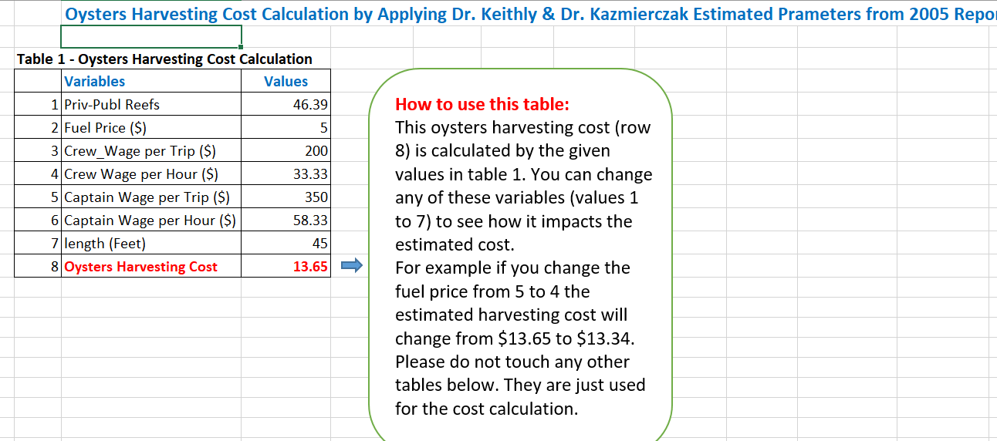
Sam Slavich motioned to accept and recommend the presented table/ cost calculation being put forth to update and replace the old Oyster Lease Damage Evaluation Board calculations, 2nd by Brad Robin. Motion carries.
Earl Melancon recommended changing the salinity maps as well
- Louis Guida and Jay Youngdahl provided a presentation on creating an oyster industry YouTube video
The idea would be to put together 5-6 pieces like the video presented for YouTube to be used as a campaign for the OTF website and social
Mitch Jurisich stated that he would like to go into the different areas and get different perspectives from the industry, need to work on cost to make it more palatable, will add to the next meeting’s agenda to take action
Brad Robin motioned to go back to item B. under New Business at this time- B. To Hear the Oyster Stock Assessment Results and the 2023/24 Oyster Season Recommendations, 2nd by Willie Daisy. Motion carries.
Sam Slavich motioned to support LDWF’s oyster season recommendations with the caveat that if going forward a change is needed that the Task Force can come forward with that change/ recommendation, 2nd by Brad Robin. Motion carries.
VII. Public Comment:
VIII. The next OTF meeting is set for Tuesday, September 19th date later change to Wednesday, September 20, 2023 for 1pm at the Airport Marketing. OTF Marketing Committee meeting set prior starting at 9:30am followed by a Health Committee meeting starting for 10am
IX. Jakov Jurisic motioned to adjourn the meeting, 2nd by Brad Robin. Motion carries.

